Validate WMI health Status and Repair or Rebuild

1. Open command prompt as administrator to check WMI status:

* winmgmt /salvagerepository
* winmgmt /verifyrepository

1. If above command output shows that Repository is not consistent, then you need to run:

* winmgmt /resetrepository [This command used to repair WMI at basic level]

1. Next Steps to validate WMI:

* Open run - type 'wmimgmt.msc' - Right click on WMI control [Local] and click on properties

As per below snapshot: WMI has corruption [some classes are missing]

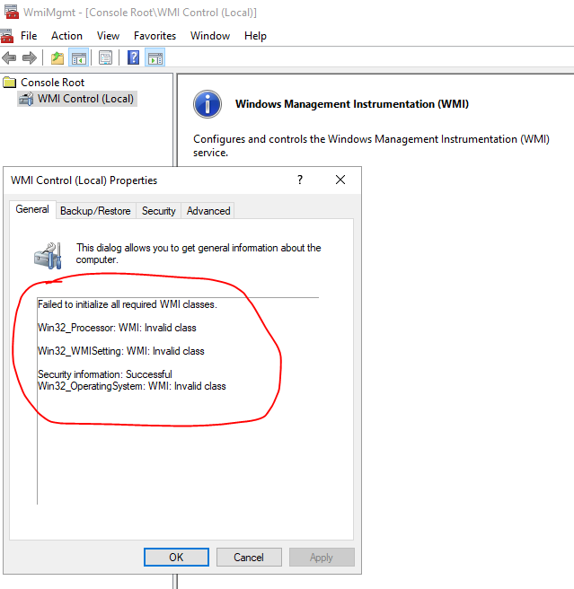

**To repair WMI run below batch script [Download and saved it in your system]:**



* **Changed its extension to ‘.bat’ then run it as administrator. Once command started then it will automatically closed on the successfully completion.**

Then need to reboot the system and validate WMI health in system [Check the step 3]

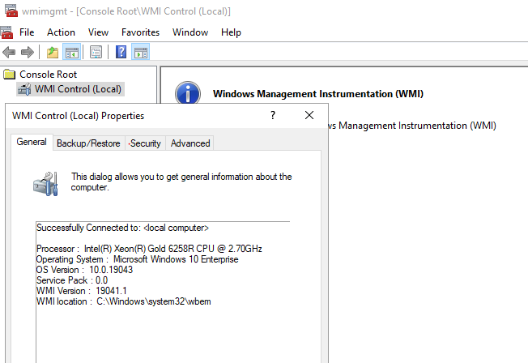

Below are the some list of WMI Errors:

1. Unable to connect to root default or rootcimv2 namespaces. It fails with the error code “0x80041002” pointing to “WBEM_E_NOT_FOUND.”
2. When you open Computer Management and Right Click on Computer Management (Local) and select Properties, you get the following error: “**WMI**: Not Found” or it hangs trying to connect
3. 0x80041010 WBEM_E_INVALID_CLASS
4. Trying to use *wbemtest*, and it hangs
5. Schemas/Objects missing
6. Strange connection/operation errors (0x8007054e)
7. You can try to run some basic command like systeminfo or hostname so you will get error while output of the command

**IMP – WMI repair might affect the other 3rd party apps or services because many services and apps are dependent on the WMI.**